**Project 1 –Static website hosting on amazon s3 (with cloudfront) without enabling public access.**

**Summary: \***This project aims to host a static website on Amazon S3 (Simple Storage Service) while using Amazon CloudFront as a content delivery network (CDN) to improve performance and reliability. Unlike traditional setups where S3 buckets are publicly accessible, this project focuses on restricting access to the S3 bucket and serving content exclusively through CloudFront.

**Diagram:**

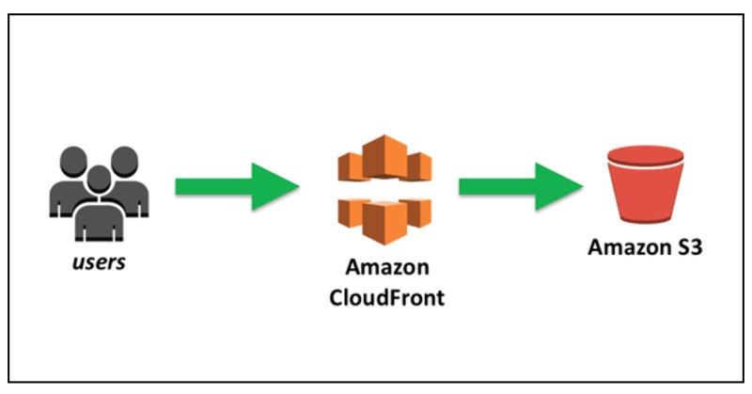

**Execution Steps:**

Here are simplified steps to host a static website on Amazon S3 with CloudFront without enabling public access.

1. *Create an S3 Bucket*: Navigate to the Amazon S3 service in the AWS Management Console. Create a new S3 bucket with a unique name.

2. *Upload Website Content*: Upload your static website content (HTML, CSS, JavaScript files, etc.) to the S3 bucket.

3. *Configure Bucket Policy*: Set a bucket policy to restrict access to only CloudFront. This policy denies all public access to the bucket and allows access only from CloudFront.

json

{

"Version": "2012-10-17",

"Statement": [

{

"Effect": "Deny",

"Principal": "*",

"Action": "s3:GetObject",

"Resource": "arn:aws:s3:::your-bucket-name/*",

"Condition": {

"StringNotEquals": {

"aws:SourceVpc": "your-cloudfront-distribution-id"

}

}

}

]

Replace "your-bucket-name" with your S3 bucket name and "your-cloudfront-distribution-id" with your CloudFront distribution ID.

4. *Create a CloudFront Distribution*: Navigate to the Amazon CloudFront service in the AWS Management Console. Create a new CloudFront distribution and configure it to use your S3 bucket as the origin.

5. *Set Origin Access Identity (OAI)*: Create an Origin Access Identity for your CloudFront distribution. This allows CloudFront to access your S3 bucket privately.

6. *Update Bucket Policy*: Update the bucket policy to allow access from the CloudFront distribution by specifying the OAI as the principal.

json

{

"Version": "2012-10-17",

"Statement": [

{

"Effect": "Allow",

"Principal": {

"AWS": "arn:aws:iam::cloudfront:user/CloudFront Origin Access Identity YOUR_OAI_ID"

},

"Action": "s3:GetObject",

"Resource": "arn:aws:s3:::your-bucket-name/*"

}

]

}

Replace "YOUR_OAI_ID" with the ID of your CloudFront Origin Access Identity.

7. *Configure CloudFront Settings*: Configure CloudFront settings like default cache behavior, alternate domain names (if using a custom domain), SSL certificate, etc.

8. *Wait for Distribution Deployment*: It may take some time for the CloudFront distribution to deploy.

9. *Test Your Website*: Access your website using the CloudFront domain name. Ensure that it loads correctly.